## U08224 Graphics and Animation

Examination Rubric

The duration of the examination is **2 hours**.

Answer ONE question from **SECTION 1** and ONE question from **SECTION 2**. There are TWO questions in each **SECTION**.

All questions carry equal marks of 25

**SECTION 1**

(1)

(a) **setup()**, **draw()** and **mousePressed()** are three commonly used, built-in methods in Processing. Considering Processing as a graphics and animation programming language, state what is the *general* role of each of them and what *relationship* do they have to each other?

**8 Marks**

(b)

* 1. What is the effect of the data declarations and the **setup()** method in the programme below?

**4 Marks**

* 1. What is the effect of the **draw()** method in the programme below?

**4 Marks**

* 1. What is the effect of the **mousePressed()** method in the programme below?

**1 Mark**

**int d = 120;**

**int W = 4 * d,**

**H = d;**

**int RightShift = 0;**

**color Red = color(255, 0, 0),**

**Yellow = color(255, 255, 0);**

**void setup() {**

**size(W, H);**

**fill(Red);**

**}**

**void draw() {**

**int i;**

**background(Yellow);**

**for(i = 0; i < 4; i++) {**

**RightShift++;**

**ellipse(i * d + d/2 + RightShift, d/2, d, d);**

**}**

**}**

**void mousePressed() {**

**RightShift = 0;**

**}**

(c) Using diagrams and text, describe the behaviour of the programme as seen by a user.

**8 marks**

(2)

(a) Why is an object oriented approach useful in graphics and animation?

**4 Marks**

1. Explain the relationship between class and object.

**3 Marks**

1. Describe the typical attributes and methods a moving **Square** class might define.

**4 Marks**

1. Write code for your **Square** class.

**5 Marks**

1. The top line of graphics below shows the evolution of a large number of random squares of various sizes and colours produced by a Processing programme. The larger graphic shows a more detailed screenshot.
2. Why would an array be a useful data structure to use here?

**3 Marks**

1. Describe how you would design and implement such a graphic using the array and the **Square** class. How is the approximate symmetry of the graphic achieved and maintained?

**6 Marks**

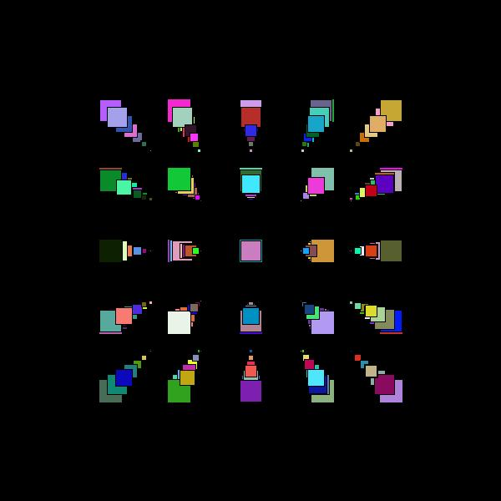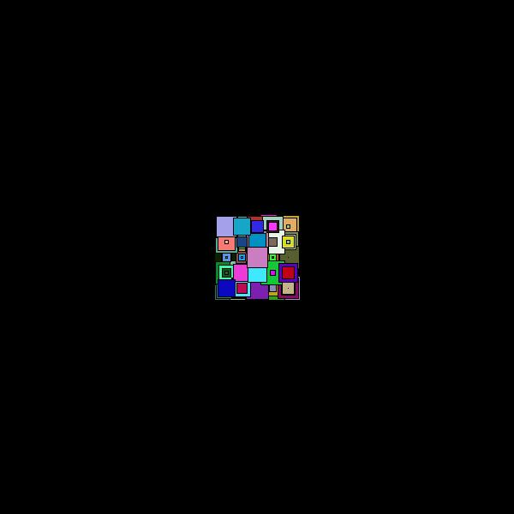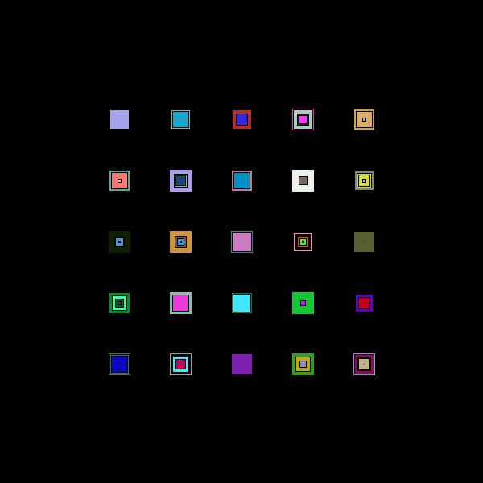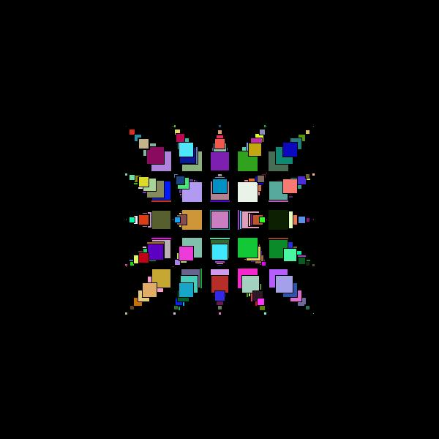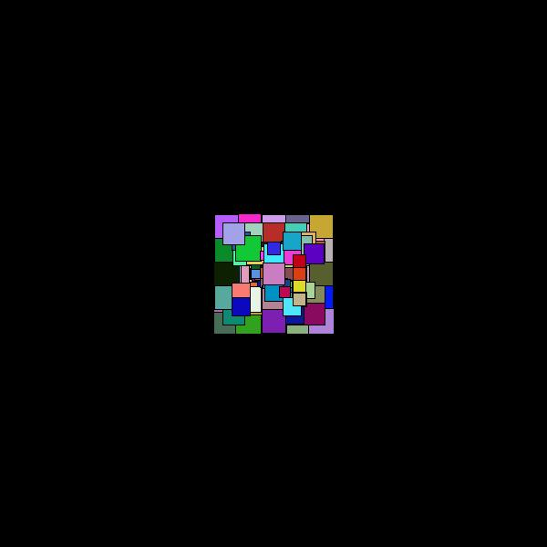

**SECTION 2**

(3) This question uses the programme on the sheet **Code For Exam Question 3**

1. Explain what the code in box A does.

**2 marks**

1. Explain what the code in box B does. In particular clearly explain the effects of **translate()** and **rotate()**.

**8 marks**

1. What is the effect of running the code in box A followed by the code in box B?

**5 marks**

1. What is the role of the Processing methods **pushMatrix()** and **popMatrix()**?

**5 marks**

1. What is the effect of running the whole programme?

**5 marks**

**Total 25 Marks**

(4)

The program below takes an image for input and outputs a mirror image – see example.

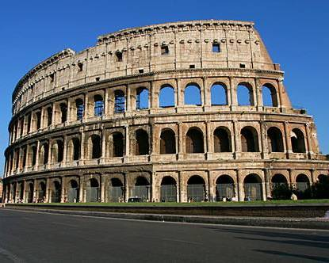

**void setup() {**

**PImage Im;**

**Im = loadImage("Colosseum.jpg");**

**size(Im.width, Im.height);**

**image(Im, 0, 0);**

**}**

**void draw() {**

**Colosseum.jpg**

**}**

**void mousePressed() {**

**int i,**

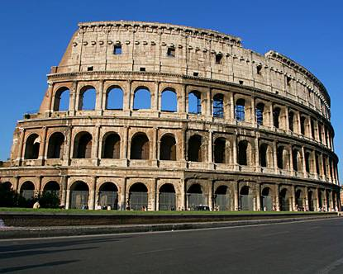

**j;**

**color Save = 0;**

**for(i = 0; i < width/2; i++) {**

**for(j = 0; j < height; j++) {**

**Save = get(i, j);**

**set(i, j, get(width - i, j));**

**set(width - i, j, Save);**

**}**

**MirrorColosseum.jpg**

**}**

**save("MirrorColiseum.jpg");**

**}**

1. What does **setup()** achieve in this program? Explain your answer.

**7 marks**

1. What does the method call **get(i, j)** achieve?

**3 marks**

1. What does the method call **set(i, j, get(width - i, j**)) achieve? K

4ppppppp

4 marks

**4 marks**

1. How does the program produce the output image **MirrorColiseum.jpg**?

**5 marks**

**6 marks**

# Total 25 Marks

**End of Examination Paper**